**STT 810**

**ICA 5**

1. Customers are entering a store at a rate of 1 every 4 minutes. Find:
   1. The probability that exactly 3 customers enter in a 15 minute period

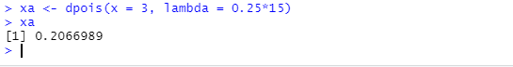

* 1. The probability that at least 12 customers enter in an hour

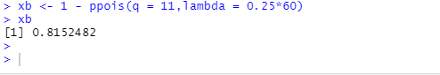

* 1. The median and 90th percentile number of customers that come in a 10 minute period

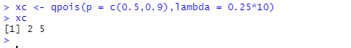

* 1. Do 10 simulations of the number of customers that come in during 2 hours.

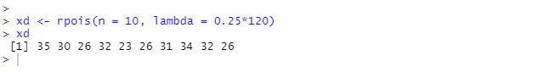

* 1. Graph the probability distribution out to a reasonable number (one that show the end-tail close to zero).

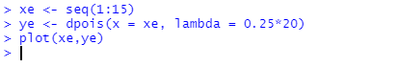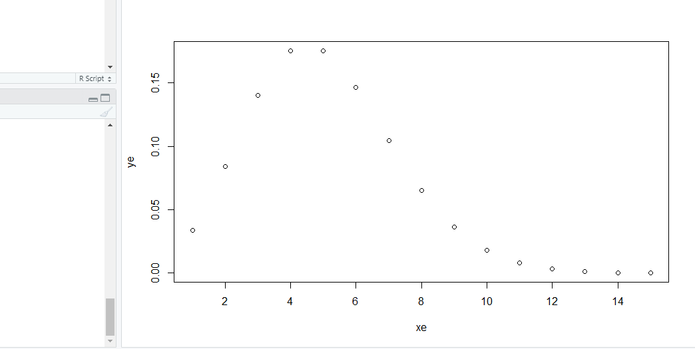

1. A certain game takes 4 minutes to play. You need to win 5 times to finish. The probability of winning each game is 40%.
   1. What is the probability of finishing in less than an hour?

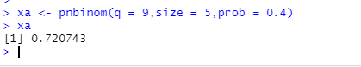

* 1. What is the probability taking at least 2 hours to finish?

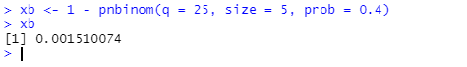

* 1. Simulate 100 plays. What is the average value?

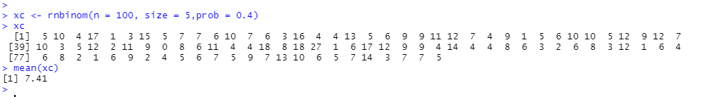

* 1. Graph the probability distribution out to a reasonable number.

